COVID Tracker Setup Guide for Employees

Table of Contents
Employee Guide for AllianceHCM COVID Tracker…………………………………………………………………… 3
Introduction to AllianceHCM COVID Tracker………………………………………………………………………….. 3
Submitting COVID Vaccination Status…………………………………………………………………………………….. 4
Submitting COVID Test Results……………………………………………………………………………………………….. 5

Management

Employee Guide for AllianceHCM COVID Tracker
With the AllianceHCM COVID tracker, businesses can automatically collect and easily manage vaccination statuses of all personnel. Vaccinated personnel can upload an image of their vaccination card to be stored in their employee file.

The AllianceHCM COVID tracker also reminds employees who haven’t given their status to do so every few days, and appropriate personnel can review the vaccination status of employees with an employee certification report. Companies can also require proof of vaccination from candidates at any point during the hiring process.

Introduction to AllianceHCM COVID Tracker

- When you login to MyPay, you may see a notification. Click ‘Read Message’ to view the notification.
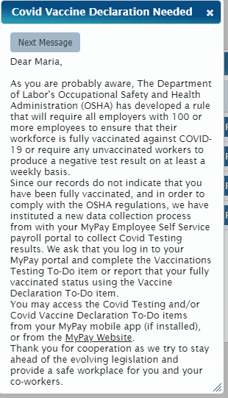

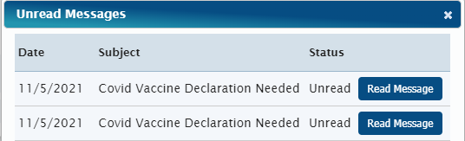

- You may also see a ‘To Do’ item for ‘COVID Vaccination Status’ and/or ‘COVID Test Results.’ These will remain open until you have completed your ‘Vaccination Status’ report and submitted your test results.

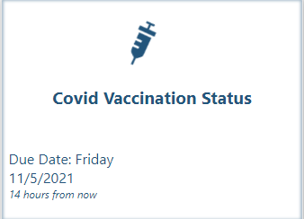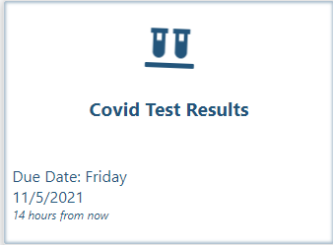

Submitting COVID Vaccination Status
Have you taken a COVID-19 vaccine? Select “Yes’ or ‘No.’
- If you select Yes, the next question is ‘Which type of vaccine did you take?’ followed by ‘When did you take the first dose?’ You can also input the date of the second dose or click ‘I have not taken my second dose yet.’ When everything is filled out, click ‘Submit.’ Once you have submitted, you can download and view your ‘COVID Vaccine Declaration’ page.

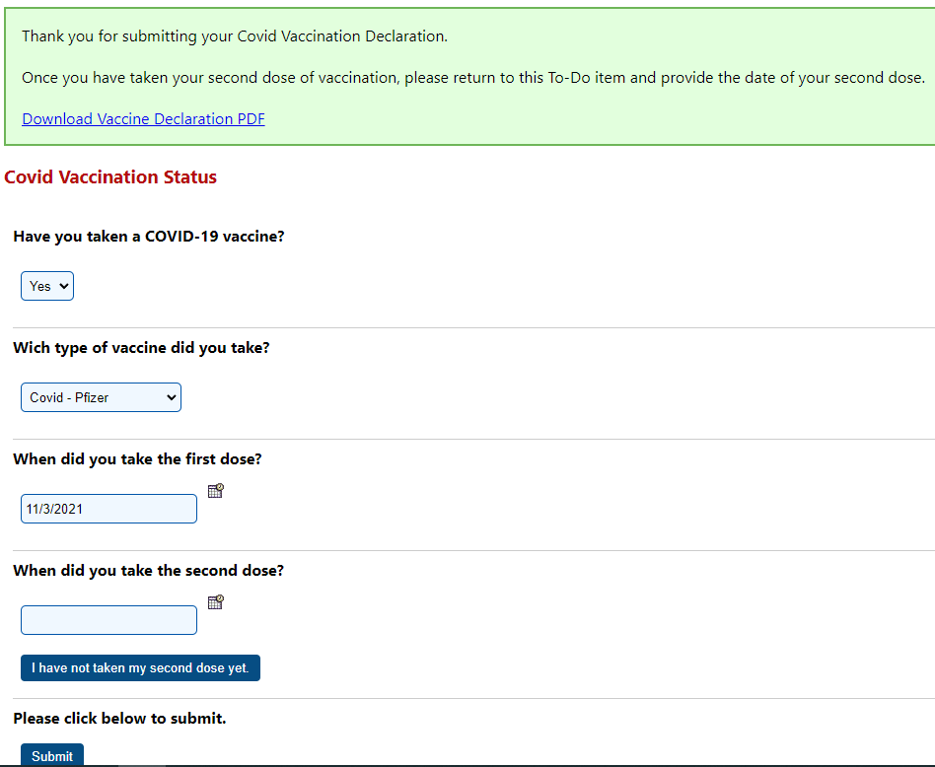

- If you select No, just click ‘Submit.’

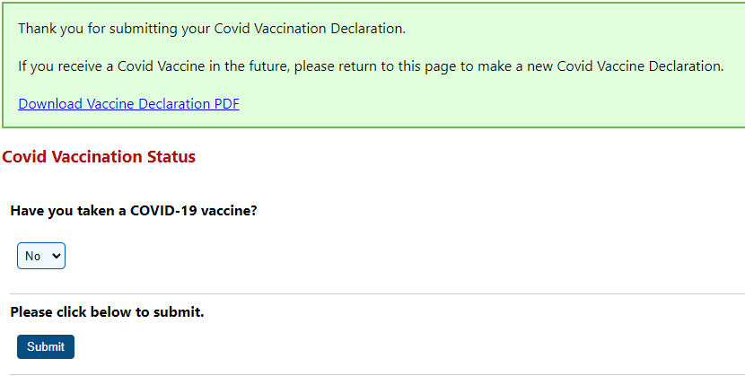

Submitting COVID Test Results
Submit a new COVID Test Result. Fill out the ‘Test Type,’ ‘Test Date,’ ‘Test Results,’ and upload or take a photo of your test results, then click ‘Submit.’
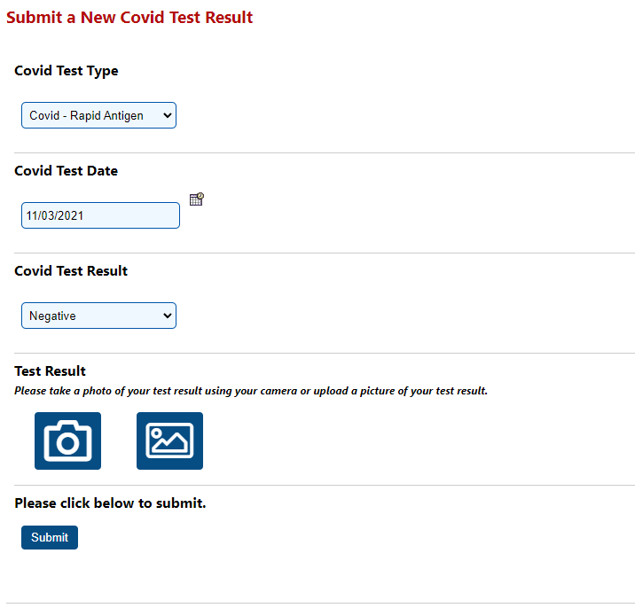

*Note: Employees can see their vaccine card and response from ‘Documents’ on their MyPay portal.

